Balance Sheet Questions
- Give an example of assets that a bank is likely to have: _____________________________________________
- Give an example of a liability that a bank is likely to have: _____________________________
- Use information in the table below to answer the question.
Assets | Liabilities
Required Reserves  10,000  Excess Reserves  5000  Loans  85,000 | Demand Deposits  100,000
Show the new amounts in the balance sheets if the customer withdraws $1000.
- Use information in the table below to answer the question.
Assets | Liabilities
Required Reserves  5,000  Excess Reserves  7500  Loans  37,500 | Demand Deposits  50,000
ZShow the new amounts in the balance sheets if the RRR is changed from 10% to 20%.
- Use information in the table below to answer the question.
Assets | Liabilities
Required Reserves  4,000  Excess Reserves  2000  Loans  34,000 | Demand Deposits  40,000
Show the new amounts in the balance sheets if a customer deposits an extra $2000.
- Use information in the table below to answer the question.
Assets | Liabilities
Required Reserves  25,000  Excess Reserves  30,000  Loans  95,000 | Demand Deposits  150,000
Show the new amounts in the balance sheets if the bank decides to create the maximum amount of loans it can create.
- Use information in the table below to answer the question.
Assets | Liabilities
Required Reserves  2,000  Excess Reserves  3000  Loans  5000 | Demand Deposits  10,000
Show the new amounts in the balance sheets if the RRR changes from 20% to 15%.
- Use information in the table below to answer the question.
Assets | Liabilities
Required Reserves  5,000  Excess Reserves  25000  Loans  20,000 | Demand Deposits  50,000
Show the new amounts in the balance sheets if the RRR is changed from 10% to 20%.
- Use information in the table below to answer the question.
Assets | Liabilities
Required Reserves  5,000  Excess Reserves  25000  Loans  20,000 | Demand Deposits  50,000
Show the new amounts in the balance sheets if the bank decides to create another $5000 of loans.
- Use information in the table below to answer the question.
Assets | Liabilities
Required Reserves  1500  Excess Reserves  1500  Loans  7000 | Demand Deposits  10,000
Show the new amounts in the balance sheets if a customer deposits an additional $500.
- Use information in the table below to answer the question.
Assets | Liabilities
Required Reserves  4,000  Excess Reserves  2000  Loans  34,000 | Demand Deposits  40,000
Show the new amounts in the balance sheets if the customer withdraws $5000.
- Use information in the table below to answer the question.
Assets | Liabilities
Required Reserves  6000  Excess Reserves  14,000  Loans  40,000 | Demand Deposits  60,000
Show the new amounts in the balance sheets if the customer withdraws $10,000.

Answers
1.
Assets | Liabilities
Required Reserves  10,000 – 100 = 9900  Excess Reserves  5000 – 900 = 4100  Loans  85,000 | Demand Deposits  100,000 – 1000 = 99000
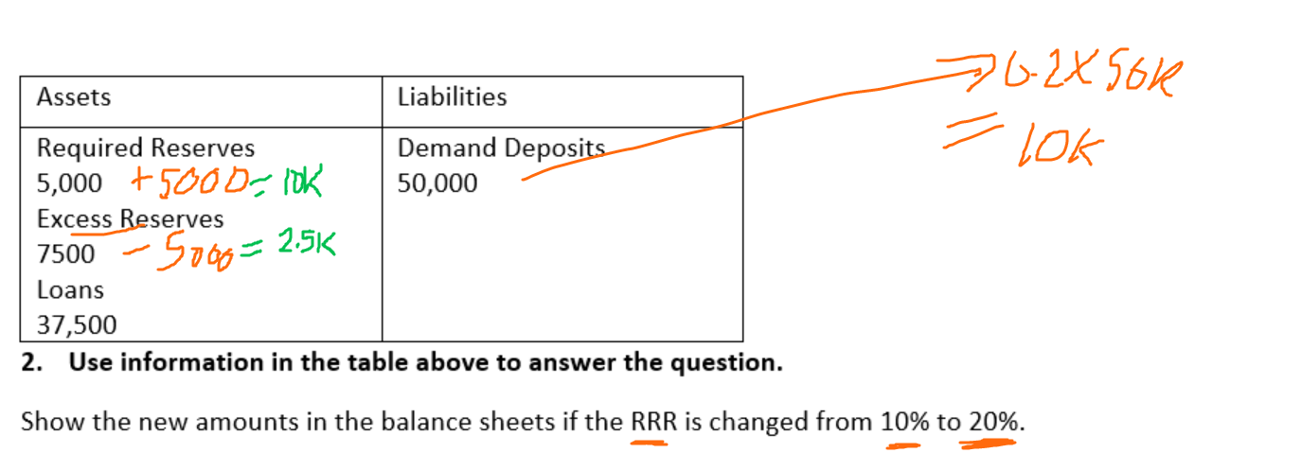
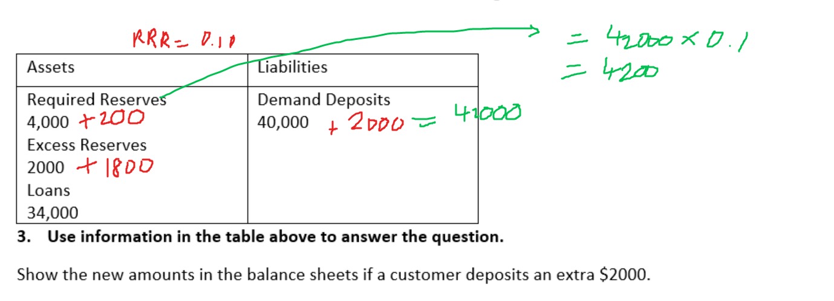
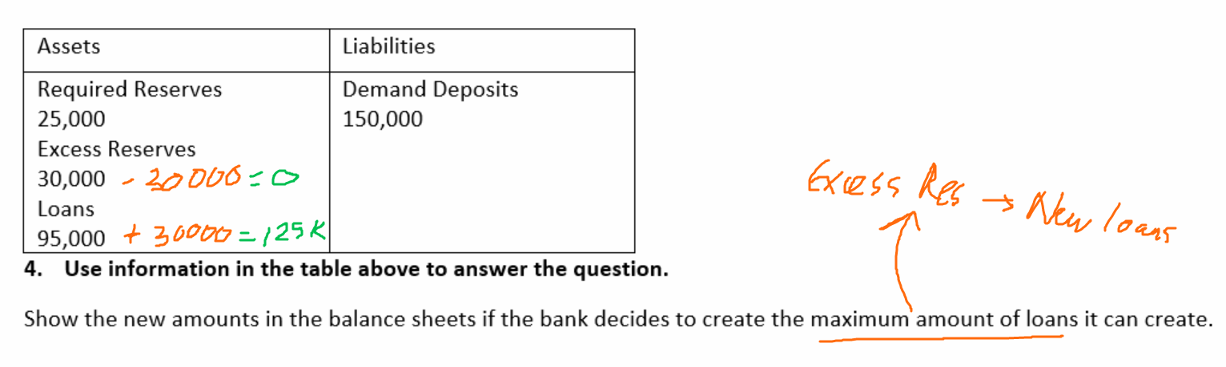
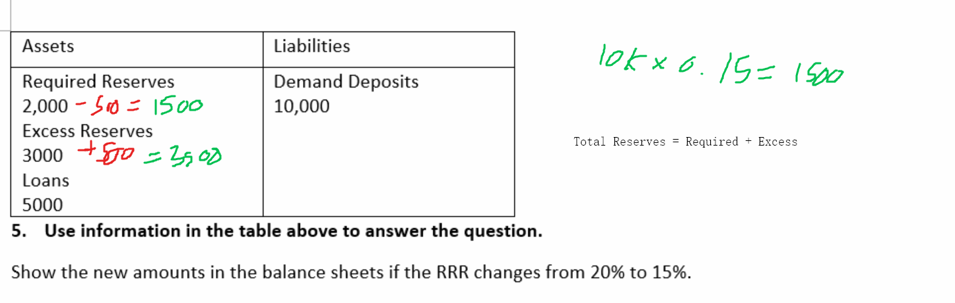
6.
Assets | Liabilities
Required Reserves  5,000 + 5000 = 10,000  Excess Reserves  25000 – 5000 = 20,000  Loans  20,000 | Demand Deposits  50,000
7.
Assets | Liabilities
Required Reserves  5,000  Excess Reserves  25000-5000 = 20000  Loans  20,000 + 5000 = 25000 | Demand Deposits  50,000
8.
Assets | Liabilities
Required Reserves  1500+75 = 1575  Excess Reserves  1500+425 = 1925  Loans  7000 | Demand Deposits  10,000 + 500 = 10,500
9.
Assets | Liabilities
Required Reserves  4,000-1000 = 3000  Excess Reserves  2000 – 2000 = 0  Loans  34,000  Bank still needs to find another 2000 to cover the decrease in deposits. Could borrow from another bank. | Demand Deposits  40,000 – 5000 = 35000
10.
Assets | Liabilities
Required Reserves  6000 – 1000 = 5000  Excess Reserves  14,000 – 9000 = 5000  Loans  40,000 | Demand Deposits  60,000-10,000 = 50,000

